**PIZZA SALES QUERIES WITH SQL**

**KPI’s:**

1. Total Revenue:

SELECT SUM(total_price) AS Total_Revenue FROM pizza_sales;

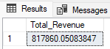

1. Average Order Value:

SELECT SUM(total_price) / COUNT(DISTINCT order_id)

AS Avg_Order_Value FROM pizza_sales;

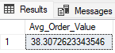

1. Total Pizza Sold:

SELECT SUM(quantity) AS Total_Pizza_Sold

FROM pizza_sales;

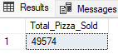

1. Total Orders:

SELECT COUNT(DISTINCT order_id)

AS Total_Orders FROM pizza_sales;



1. Average Pizza Per Order:

SELECT CAST(CAST(SUM(quantity) AS decimal (10,2)) /

CAST(COUNT(DISTINCT order_id) AS decimal (10,2)) AS decimal (10,2))

AS Average_Pizza_Per_Order FROM pizza_sales;

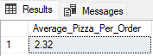

**For charts**

1. Daily Trend for Total Orders:

SELECT DATENAME(DW, order_date) AS Order_Day,

COUNT(DISTINCT order_id) AS Total_Orders

FROM pizza_sales

GROUP BY DATENAME(DW, order_date);

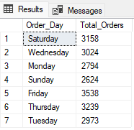

1. Monthly Trend for Total Orders:

SELECT DATENAME(MONTH, order_date) AS Month_Name,

COUNT(DISTINCT order_id) As Total_Orders

FROM pizza_sales

GROUP BY DATENAME(MONTH, order_date)

ORDER BY Total_Orders DESC;

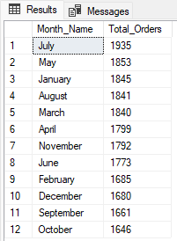

1. Percentege of Sales by Pizza Category:

SELECT pizza_category, CAST(SUM(total_price) AS DECIMAL(10,2)) AS total_revenue,

CAST(SUM(total_price) * 100 /

(SELECT SUM(total_price) FROM pizza_sales) AS DECIMAL(10,2)) AS PCT

FROM pizza_sales

GROUP BY pizza_category;

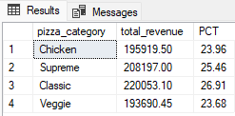

1. Percentege of Sale by Pizza Size

SELECT pizza_size, CAST(SUM(total_price) AS DECIMAL(10,2)) AS total_revenue,

CAST(SUM(total_price) * 100 /

(SELECT SUM(total_price) FROM pizza_sales) AS DECIMAL(10,2)) AS PCT

FROM pizza_sales

GROUP BY pizza_size

ORDER BY PCT DESC;

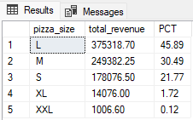

1. Total Pizza Sold by Pizza Category

SELECT pizza_category, SUM(quantity) AS Total_Quantity_Sold

FROM pizza_sales

WHERE MONTH(order_date) = 2

GROUP BY pizza_category

ORDER BY Total_Quantity_Sold DESC;

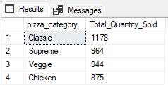

1. Top 5 Pizza by Revenue

SELECT TOP 5 pizza_name, SUM(total_price)

AS Total_Revenue FROM pizza_sales

GROUP BY pizza_name

ORDER BY Total_Revenue DESC;

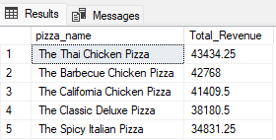

1. Bottom 5 Pizza by Revenue

SELECT TOP 5 pizza_name, SUM(quantity)

AS Total_Revenue FROM pizza_sales

GROUP BY pizza_name

ORDER BY Total_Revenue ASC;

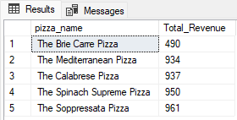

1. Top 5 Pizza by Quantity

SELECT TOP 5 pizza_name, SUM(quantity)

AS Total_Quantity FROM pizza_sales

GROUP BY pizza_name

ORDER BY Total_Quantity DESC;

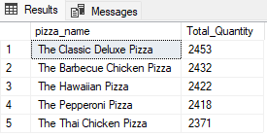

1. Bottom 5 Pizza by Quantity

SELECT TOP 5 pizza_name, SUM(quantity)

AS Total_Quantity FROM pizza_sales

GROUP BY pizza_name

ORDER BY Total_Quantity ASC;

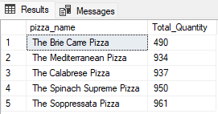

1. Top 5 Pizza by Total Order

SELECT Top 5 pizza_name, COUNT(DISTINCT order_id)

AS Total_Orders

FROM pizza_sales

GROUP BY pizza_name

ORDER BY Total_Orders DESC;

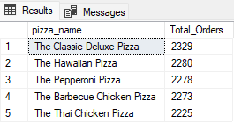

1. Bottom 5 Pizza by Total Order

SELECT Top 5 pizza_name, COUNT(DISTINCT order_id)

AS Total_Orders

FROM pizza_sales

GROUP BY pizza_name

ORDER BY Total_Orders ASC;

